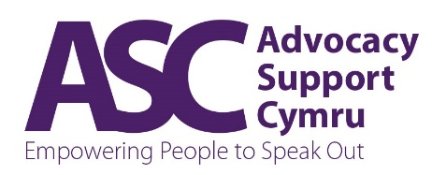
Talking Mats – please complete a form for each person booking

Name (please print as you would like on certificate):

Organisation: | Position:
Address:
Postcode:
Telephone (please provide mobile number):
Email:

Please tick date:

Course dates: | Tuesday 12th May & Tuesday 2nd June 2026
Course dates: | Tuesday 8th September & Tuesday 29th September 2026

My group / organisation:

* | Type | Tick
A | Individual community member/resident
B | Third sector/voluntary/community organisation
C | Public/statutory sector
D | Private organisation
E | Other
Refreshments will be provided during both of the two half days duration of the course.
Please note: Payment is expected on booking, your place on the course will only be confirmed once payment has been received. Payment is acceptable by cheque or by BACS.

Payment (please tick) √

I enclose cheque payment (made payable to Advocacy Support Cymru) for £200.00 | I wish to be invoiced for £200.00 & pay by BACS using the following details:  Purchase order number (if applicable):

Cancellation Fee: For pre-payments, cancellation 1 week or less prior to the course incurs 100% of the booking fee. Final payment must be received 1 working week in advance of the booked course. Please inform us ASAP if you are unable to attend; we are happy to take a replacement for the original participant booked up to 48 hours prior to a course commencing.
ASC reserves the right to cancel a Talking Mats delivery if minimum viable numbers of 4 participants are not achieved. On this basis, those booked will be entitled to full refunds or will be able to transfer payments made to a subsequent Talking Mats course.

The information I have provided is correct and I understand the conditions of the booking.
Signed… …………………………………………………………………..
Name:……………………………………………………………………………………………………….

Organisation (if applicable):……………………………………………………………………………….
Date: ……………………………………

Please return completed booking form and payment (if applicable) by post to:

Advocacy Support Cymru, Charterhouse 1, Links Business Park, St Mellons, Cardiff, CF3 0LT
Or scan and return booking form by email to training@ascymru.org.uk or send by fax to 029 2073 5620

Please advise where you heard about our Talking Mats delivery? Tick all appropriate...
Via Google Search Via ASC website
Advertisement Through Social media
Via C3SC events portal Via SCVS events portal
Other…………………………………………………………………

